Template and submission instructions

Your submission will be done with a single file, up to 6 pages maximum. Your document will be used in two ways:
1. The first page will provide a one-page summary. This page will be used in the book of abstracts for the conference. This abstract will be the first page of your file. Do not start the introduction here. Skip to the next page for your introduction.
2. The complete document, which should not exceed 6 pages including the first-page summary, will be used for the conference proceedings published by Journal of Physics: Conference Series.
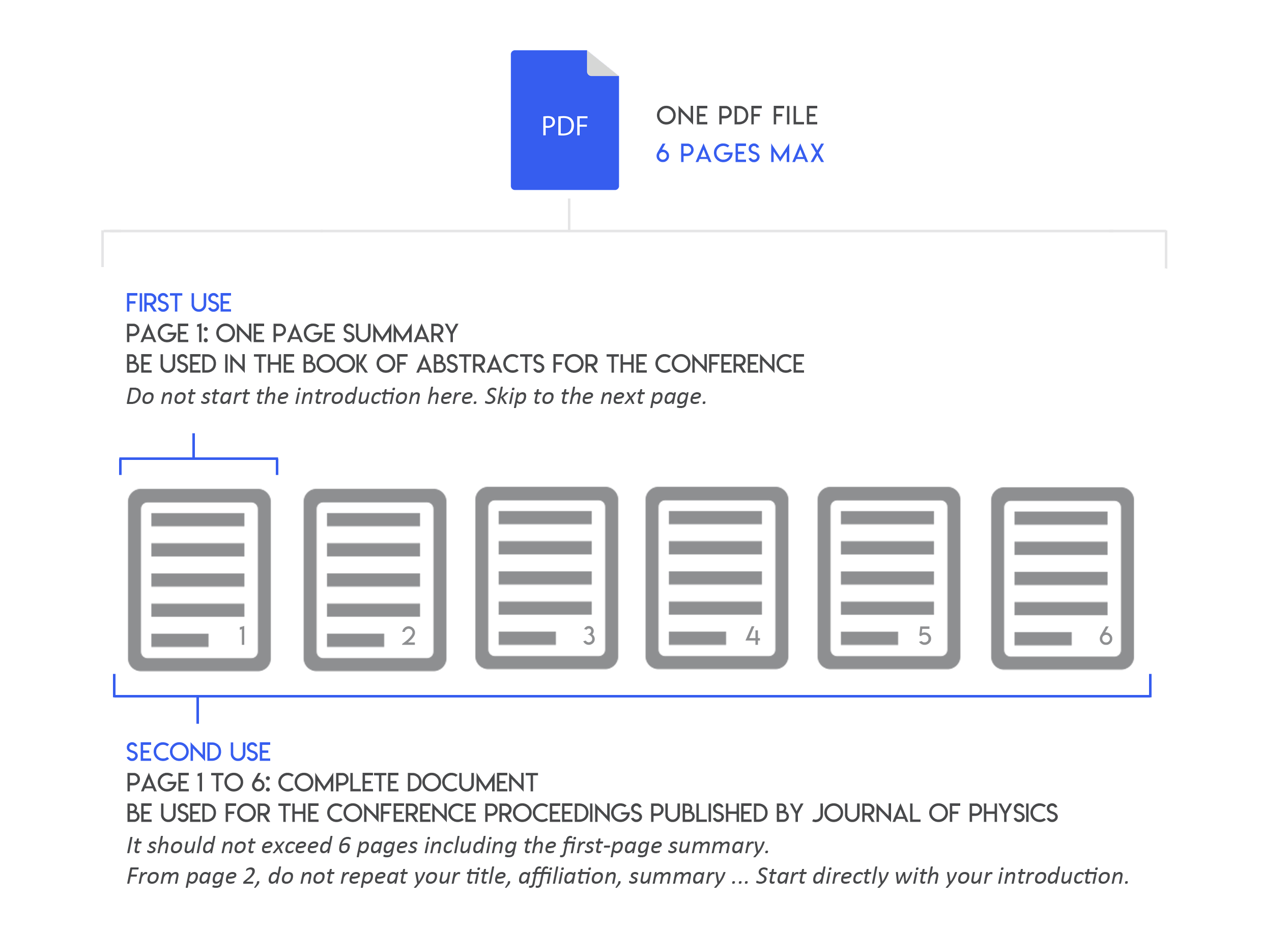
Your document should be submitted in pdf format on the submission platform: https://esfss2018.sciencesconf.org/

Instructions:
- Page format: A4 portrait
- Margins: Top, Left and Right, Bottom: 1,9cm
- Line spacing: 1
- Use UK English language

Type Title of Document Here [Main Title style]
[Main Title Style]: Times new Roman, Font size 14, Bold, centred

John Firstauthor¹, Joan Secondauthor² and Marie Thirdauthor³
[Authors list]: Times new Roman, font size 11, centred. Presenting author in bold, co-authors separated by commas and last author by “and” without comma. All authors full first names. No initials and no middle names.

¹Department, Organisation, Country
²Department, Organisation, Country
³Department, Organisation, Country
[Institutions list]: Times new Roman, font size 11, italics, centred.
No postal addresses, no ZIP codes, no cities

john.firstauthor@university.org
Email address of presenting author only (Times new Roman, font size 10, centred).
Ensure it is not formatted as email hyperlink (i.e. blue and underlined).

Abstract [Heading 1 style]
[Heading 1 style]: Times new Roman, in capital letters, font size 11, bold. Document abstract goes here. It should include a concise description of the results and findings of the research.

[Body Text style] Lorem ipsum dolor sit amet, an pro dicunt pertinacia. Per mundi accusata imperdiet at, te diam mucius per. Qui convenire pertinacia in, ei sea admodum epicuri appellantur. Magna adipisci pericula his ea. Ea nam accusam fierent eligendi, in ius hinc officiis efficiantur.
Lorem ipsum dolor sit amet, an pro dicunt pertinacia. Per mundi accusata imperdiet at, te diam mucius per. Qui convenire pertinacia in, ei sea admodum epicuri appellantur. Magna adipisci pericula his ea. Ea nam accusam fierent eligendi, in ius hinc officiis efficiantur. Elit erat voluptua ei est, pro civibus detraxit ne, minim aliquid persecuti vim ex. Ei malis abhorreant has, eam no modus probatus. Vix unum copiosae conceptam id, at agam discere consectetuer vix. Cu pro urbanitas complectitur, an iriure nostrud docendi nam. Facer augue facilis eos ei, et nec vide mazim mollis.

Saperet copiosae et sed. Choro iudico oblique cu eos, mentitum scriptorem per eu. Ea eam falli partem facete, eos in putant impedit fabellas, te per vitae docendi. Elit latine volumus cu quo, lobortis indoctum rationibus et ius. Nulla antiopam et vim, nec velit nominavi ex.

[Body Text style]: Times New Roman, font size 11, text justified
KEYWORDS [HEADING 1 STYLE]:
At least 3 keywords are required with all letters in lower case and not bold. A list of suggested keywords is provided below.
[Keywords style] Suggested Keywords: fire chemistry; modeling; human behavior; risk assessment; performance-based design; statistics; structural response; structural design; suppression; detection; forensics; smoke management; flame spread; fire growth; compartment fires; heat transfer; fluid dynamics; CFD; wildfires; explosion; ignition.
[Keywords style]: Times new Roman, font size 11, italics, text justified

Your document will be used in two ways:

- The first page will provide a one-page summary. This page will be used in the book of abstracts for the conference. Do not start the introduction here. Skip to the next page.page.

- The complete document, which should not exceed 6 pages including the first-page summary, will be used for the conference proceedings published by Journal of Physics: Conference Series.

DO NOT START HERE. SKIP TO THE NEXT PAGE.
Introduction [Heading 1 style]
[Heading 1 style]: Times new Roman, in capital letters, font size 11, bold

[Body Text style] Lorem ipsum dolor sit amet, an pro dicunt pertinacia. Per mundi accusata imperdiet at, te diam mucius per. Qui convenire pertinacia in, ei sea admodum epicuri appellantur. Magna adipisci pericula his ea. Ea nam accusam fierent eligendi, in ius hinc officiis efficiantur. Elit erat voluptua ei est, pro civibus detraxit ne, minim aliquid persecuti vim ex. Ei malis abhorreant has, eam no modus probatus. Vix unum copiosae conceptam id, at agam discere consectetuer vix. Cu pro urbanitas complectitur, an iriure nostrud docendi nam. Facer augue facilis eos ei, et nec vide mazim mollis.

[Body Text style]: Times New Roman, font size 11, text justified

Supplementary Heading 1 [Heading 1 style]
[Body Text style] Lorem ipsum dolor sit amet, an pro dicunt pertinacia. Per mundi accusata imperdiet at, te diam mucius per. Qui convenire pertinacia in, ei sea admodum epicuri appellantur. Magna adipisci pericula his ea.

Supplementary Heading 2 [Heading 2 style]
[Heading style 2]: Times new Roman, font size 11, bold

[Body Text style] Lorem ipsum dolor sit amet, an pro dicunt pertinacia. Per mundi accusata imperdiet at, te diam mucius per. Qui convenire pertinacia in, ei sea admodum epicuri appellantur. Magna adipisci pericula his ea.

Supplementany Heading 1 [Heading 1 style]
[Body Text style] Lorem ipsum dolor sit amet, an pro dicunt pertinacia. Per mundi accusata imperdiet at, te diam mucius per. Qui convenire pertinacia in, ei sea admodum epicuri appellantur. Magna adipisci pericula his ea.

Supplementary Heading 2 [Heading 2 style]
[Body Text style] Lorem ipsum dolor sit amet, an pro dicunt pertinacia. Per mundi accusata imperdiet at, te diam mucius per. Qui convenire pertinacia in, ei sea admodum epicuri appellantur. Magna adipisci pericula his ea.

Optional DOcument Components

Nomenclature Listing (If APplicable) [Heading 1 style]
[Body Text style] If symbols are used extensively, a nomenclature listing, arranged alphabetically, must be included in the paper immediately following the Keywords listing. All subscript and superscript symbols appear separately in the listing. If units of measure are provided, place them in parentheses next to the applicable term. A table, as provided below, can be used to simplify two column layout of nomenclature list.
a | apparatus dimension | T_{o} | ambient temperature (K)
c_{p} | specific heat | t | time (s)
H | half-length of the window (m) | x | dimension into glass (m)
h | heat transfer coefficient (W/m²k) | y | away from edge (m)
I | absorbed radiant heat flux (kW/m²) | z | along edge (m)
k | thermal conductivity | Greek
L | glass thickness (m) |  | emissivity
l | decay length (m) |  | thermal diffusivity (m²/s)
q | heat flux (kW/m²) | subscripts
s | shaded length (m) | _{L} | ambient side of glass pane
T | temperature (K) | ₀ | fire side of glass pane

Abbreviations and acronyms
[Abbreviations and acronyms style] Write out abbreviations or acronyms at their first mention in the text followed by the abbreviation or acronym in parenthesis.

Symbols
[Symbols style] Symbols in the text of the document should be italic. Symbols must be defined either in the text or in a Nomenclature Listing table. Symbol definitions should include the units of the symbol.

Equations
[Equation style] Equations are numbered consecutively in the text and referred to as Eq. 1, etc. If the equation reference is the first word in a sentence, then spell the word Equation. An Equation style has been provided which includes a right aligned tab stop for the equation number and extra space after the paragraph.
$ρC\frac{∂T}{∂t}=λΔT+\dot{q}$ (1)

Figures
- All figures must have a number and caption [Caption style], i.e., Fig. 1. Fire in unoccupied building. A single space separates the word Fig. and the figure number, as well as the figure number and caption. Number figures consecutively with Arabic numerals.
- Figure captions are centered below the figure, in sentence case with a period at the end.
- In the text, references to figures are numbered consecutively and referred to as Fig. 1, etc.
- Figures are centered.

Fig. 1. Figure caption, sentence case, with period at the end. [Caption style]

Tables [Heading 2 style]
- All tables must have a number and title [Table Title style], i.e., Table 1. Heat fluxes selected for the preheating region. A single space separates the word Table and the table number as well as the table number and title. Number tables consecutively with Arabic numerals.
- Table titles are placed above the table, centered, in sentence case, with a period at the end.
- Tables are centered.

Table 1. Table title, sentence case with period at the end. [Table Title style]
Column 1 | Column 2 | Column 3^{b}
Left align text in table rows for better legibilityª. | 31 | 449.6
Sample text | 30 | 88.8
Sample text | 29 | 516.5
Sample text | 29 | 6.4

ªTable footnotes are referenced by superscript letters
^{b}Decimal alignment of numbers in columns improves legibility

References [Heading 1 style]
- Indicate references in the text using full-size numbers in brackets, i.e., [1]. References are numbered consecutively in the text.
- Include the full title in the references list [Reference style]. The reference style formats the indented paragraph and applies consecutive numbers to items in the list.
- DOI citations should be included in references where available. DOIs can be found by inserting reference text at the following site: http://www.crossref.org
- References are fully justified.

- McCaffrey, B.J., Quintiere, J.Q. and Harkleroad, M.F. (1981) Estimating Room Temperatures and the Likelihood of Flashover Using Fire Test Data Correlations, Fire Technology 17:98-119, http://dx.doi.org/10.1007/BF02479583
- Drysdale, D., An Introduction to Fire Dynamics, John Wiley and Sons, Chichester, 1985, p. 146.
- Heskestad, G., “Fire Plumes,” The SFPE Handbook of Fire Protection Engineering (2nd ed), DiNenno P.J. (ed.), National Fire Protection Association, Quincy, MA 02269, 1995, p. 2/9.
- Hall, J.R., “On People and Chance: the ‘Hard’ Facts about the ‘Soft’ Branches of Fire Safety Science,” Fire Safety Science -- Proceedings of the Sixth International Symposium, International Association for Fire Safety Science, 2000, pp. 23-40.

